Tutorial 5 - Recursion
Week of 1st March 2010 (Solutions)
1.
  - Write a recursive solution along with its Java code to reverse an integer array (not necessarily sorted). You cannot use any additional arrays in your solution.

Answer:
In order to reverse an array, we can switch the first and last elements of the array and then reverse the other elements in between. Note how we have broken the problem into a sub-problem of the same type. With this method, we have two base cases: 1) when there are 2 elements left, we just need to do a switch and no recursive call is needed, 2) when there is only 1 element left, no switch can be done and no recursive call is needed.

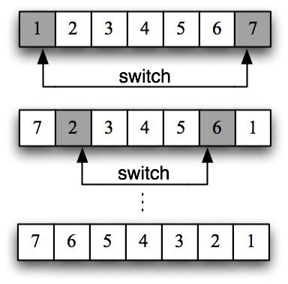

public static int[] reverse(int[] array) {
return reverse(array, 0, array.length-1);
}

public static int[] reverse(int[] array, int start,
int end) {
// Base case: one element left
if(end == start) return array;

// Switch elements at start and end indices
int temp = array[start];
array[start] = array[end];
array[end] = temp;

if(end == start + 1) {
// Base case: two elements left
return array;
} else {
// Recursive call
return reverse(array, start+1, end-1);
}
}

Note that we are able to use the same method name reverse for the two methods because they have different number of parameters (method overloading). Method overloading is useful here because the first method public static int[] reverse(int[] array) is essentially a wrapper for starting the recursive call of the second method. In other words, calling the second method directly with reverse(array, 0, array.length-1) will achieve the same effect. Hence the first method should have the same name as the second.

  - Using methods from the String class, write a recursive solution along with its Java code to check if a given String is a palindrome.

Answer:
Our approach for this problem is similar to the solution for Q2a. If a given String is a palindrome, then its first and last letters must be the same and the letters in between must also be a palindrome. Again, we have broken the problem into a sub-problem of the same type. The base cases are: 1) when there are two letters left, we just need to check that they are the same letter, 2) when there is only 1 letter left, we return true since a letter is a palindrome.

public static boolean isPalindrome(String str) {
// Base case: 1 letter left
if(str.length() == 1) return true;
// Base case: 2 letters left
if(str.length() == 2) {
return (str.charAt(0) == str.charAt(1));
}

// Compare first and last letters
if(str.charAt(0) != str.charAt(str.length()-1)) {
return false;
}

// Recursive call
return isPalindrome(str.substring(1, str.length()-1));
}

Note that str.substring(startIndex, endIndex) returns the substring of str from startIndex up to (endIndex – 1).

  - Write a recursive solution along with its Java code to find the smallest integer in an integer array. You are not allowed to use the code provided by your lecture notes for solving the k-th smallest element (by specifying k=1).

Answer:
The recursive formulation to this problem is as follows: the smallest integer in an integer array is the smaller element between the first element of the array and the smallest of the remaining elements in the array. There is only one base case here: when there is only 1 element to consider (the last element), that element is the smallest element.

public static int smallest(int[] array) {
return smallest(array, 0);
}

public static int smallest(int[] array, int start) {
// Base case: 1 element left (last element of the array)
if(start == array.length-1) return array[start];

// Recursive call
int num = smallest(array, start+1);

// Return the smaller value
return num < array[start] ? num : array[start];
}

Note that we have used the conditional operator in the return statement. This is shorthand of writing:

if(num < array[start])
return num;
else
return array[start];

  - Compare the advantages and disadvantage of the recursive solutions and iterative solutions of all these 3 questions.

Answer:
In 3 questions above, both recursion solution and iteration solution have the same time complexity (O(n) ). Although using recursive approach might make our method simpler and more intuitive, it also costs a large amount of stack memory to store the recursive calls if the number of calls is high.

- Refer to the following method

public static int recur(int n) {
if (n == 1 || n == 2) return 1;
return (n % 2 == 0)? (recur(n -1) + recur(n -2) +
recur(n - 3)) :(recur(n - 1) + recur(n - 2));
}

- How many times is recur (2) called as the result of calling recur (6)?
Answer:
The method above can be described by the following recursive function:

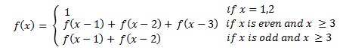
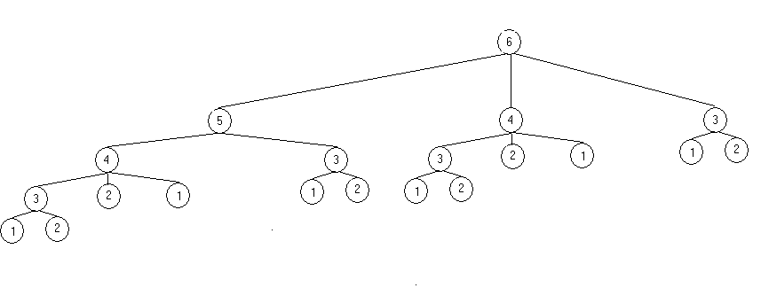
According to our diagram, recur (2) is called 6 times.

- Write a better method is calculate recur (n) so that each recur (1), …, recur (n -1) should only be calculated once.
Answer:
The method above is a good illustration to show that recursive approach can sometimes be very inefficient because it calls the result from the sub problems so many times. To prevent such unnecessary calls, we will apply the top-down approach by calculating recur (3), recur (4) , …, recur (n -1) and store them in an array for further use.
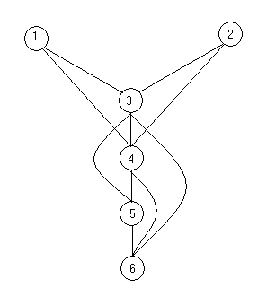
A top-down approach without using recursion

public static int recur (int n){
//Base case where n = 1,2
if (n <= 2) return 1;

//Create new array to store the result from sub problems
int[] arr = new int[n + 1];

//Calculate recur (3), recur (4), ..., recur(n)using the top-//down approach and store them in the array

for (int i = 1 ; i <= n ; i++){
if (i <= 2) arr[i] = 1;
else arr[i] = (i % 2 == 0? arr[i -1] + arr[i - 2]
+ arr[i -3]: arr[i -1] + arr[i - 2]);
}
//Return the result recur (n)
return arr[n];
}

- We assume that our array doesn’t contain duplicates. Base on the binarySearch method in the lecture note:

  - Write a recursive method ternarySearch that will search for an integer in a sorted array by dividing the array into 3 parts.

Answer: In ternary search, we have 2 midpoints and together with the start point and end point, they divide our array into 3 equal intervals. By comparing the value of our integer with mid1 and mid2, we will know which interval our integer may belong to and apply ternarySearch on that interval.
start
mid1
mid2
end
Interval1
Interval3
Interval2
public int ternarySearch (int[] arr, int n, int start, int end) {
//Base case: the integer n cannot be found
if (start > end) return -1;
//Find 2 midpoints
int mid1 = (start*2 + end) /3;
int mid2 = (start + end*2)/3;
//Case1: n may belong to the first interval
if(n < arr[mid1]) return ternarySearch(arr, n, start, mid1 - 1);
//Case2: n is equal to mid1
else if (n == arr[mid1]) return mid1;
//Case3: n may belong to second interval
else if (n > arr[mid1] && n < arr[mid2]) return
ternarySearch(arr, n,mid1 + 1, mid2 -1);
//Case4: n is equal to mid2
else if (n == arr[mid2]) return mid2;
//Case5: n may belong to third interval
else return ternarySearch(arr, n, mid2 + 1, end);
}

  - Write a recursive method modifiedBinarySearch that will search for an integer in a sorted array and return the location of the integer which is nearest to it. If there are 2 nearest integers, the lower location will be returned. For example, search for 4 in {1, 2, 3, 4, 9} will return 3 while search for 11 in {2, 3, 5, 7, 13, 15} will return 4.

Answer: This problem is similar to binary search: if the integer is found in the array, it will return its location. However, if there is no match, it will return the location of the integer which is nearest to our integer. Our base case is when the array is empty, in which we will return -1. Otherwise, we will find the midpoint of our array and compare it with our integer. If a match is found, we will return the location of the midpoint. If the midpoint is smaller, we will apply modifiedBinarySeach for the first half of the array. Next, the result will be compared with the midpoint, in which the nearer element to our integer will be returned. For the case when midpoint is larger, we will apply modifiedBinarySeach for the second half of the array and the result will be compared with the midpoint.
Case 1: a = arr[mid]. Return mid
Case 3: a > arr[mid]. Let b = modifiedBinarySearch(arr, a, mid+1 , end) . We compare |a – arr[b]| and |arr[mid] - a|. The nearer element will be returned.
mid
Case 2: a < arr[mid]. Let b = modifiedBinarySearch(arr, a, start, mid -1). We compare |a – arr[b]| and |arr[mid] - a|. The nearer element will be returned.
mid
mid
b = modifiedBinarySearch(arr,
a, start , mid - 1)
b = modifiedBinarySearch(arr,
a, mid+1 , end)

public static int modifiedBinarySearch (int[] arr, int a, int start, int end){
//Base case: The array is empty
if(start > end) return -1;
//Find the midpoint
int mid = (start + end) / 2;
//The return value, initially set it to 0.
int returnValue = 0;
//Case 1:Return the midpoint if a is equal to midpoint
if (a == arr[mid]) returnValue = mid;
//Case 2: a is smaller than the midpoint
else if (a < arr[mid]) {
//Recursion call for the first half of the array
int b = modifiedBinarySearch (arr, a, start, mid - 1);
//If the first half is empty then the nearest element is
//the midpoint
if (b == -1) returnValue = mid;
//Otherwise we need to compare between arr[b] and
// arr[mid] to choose the element which is nearer to a
else returnValue = (Math.abs (a – arr[b]) <= Math.abs (a
– arr[mid])? b: mid);
}else {
//Recursion call for the second half of the array
int b = modifiedBinarySearch (arr, a, mid + 1, end);
//If the second half is empty then the nearest element is
// the midpoint
if (b == -1) returnValue = mid;
//Otherwise we need to compare between arr[b] and arr[mid]
//to choose the element which is nearer to a
else returnValue = (Math.abs (a – arr[b]) < Math.abs (a –
arr[mid])? b: mid);
}

return returnValue;
}

  - How can part b be modified such that it still returns the correct answer in case duplicates in array are allowed?

Answer: In case the value at returnValue index has duplicates, we need to traverse the array backward until we reach the duplicate that has the lowest index and return it as the desired result. This can be done by adding a single while loop before the return line:

while (returnValue -1 >= 0 && arr[returnValue - 1] == arr[returnValue]) returnValue--;

- Given some amount of money (in cents, ¢), write a recursive solution along with its Java code to count the number of ways we can represent the money using coins. The coins are in the following denominations (¢): 1, 5, 10, 20, 50, and 100. For example:

  - 3¢ can be represented in 1 way (3 × 1¢).
  - 5¢ can be represented in 2 ways (5 × 1¢, or 1 × 5¢).
  - 10¢ can be represented in 4 ways (10 × 1¢, 2 × 5¢, 1 × 5¢ + 5 × 1¢, or 1 × 10¢).

Hint: Be careful not to double count.

Answer:
This problem can be re-formulated as follows. The number of ways to represent an amount of money is the number of ways to use just one coin denomination plus the number of ways to represent the remaining money (using coins smaller than the denomination already used). For example, the number of ways to represent 17¢ is:

- Using 1 × 10¢ coins + number of ways to represent (17 – 10)¢ using 5¢ or 1¢ coins, plus
- Using 3 × 5¢ coins + number of ways to represent (17 – 15)¢ using 1¢ coins, plus
- Using 2 × 5¢ coins + number of ways to represent (17 – 10)¢ using 1¢ coins, plus
- Using 1 × 5¢ coins + number of ways to represent (17 – 5)¢ using 1¢ coins, plus
- Using 17 × 1¢ coins (no remainder)

By controlling the denominations that can be used to represent the money, we can ensure that there is no double counting. So all we need is a method that takes as arguments: the amount of money to represent, and the maximum coin denomination that it can use.

static final int [] coins = {1, 5, 10, 20, 50, 100};
// This constant holds all the possible coin values

public static int count(int money, int max_index) {
// This method returns the number of ways to represent some
// amount of [money] using values in the constant [coins] up to
// [max_index]. For example if [max_index] is 2, then we can
// only use coins[0], coins[1], and coins[2] (1¢, 5¢, and 10¢).

// Base case: if money is less than 1¢, return 0 ways
if(money <= 0) return 0;

// Initialize the number of ways to represent the
// [money] to 0.
int num_of_ways = 0;

// We consider using each [coin] to represent the [money] one
// by one from [max_index] to 0.
for(int i = max_index; i >= 0; --i) {

if(i == 0) {
// coin[0] = 1 cent, add 1 way to represent [money]
++num_of_ways;
} else if(money == coins[i]) {
// if [money] = some coin value, add 1 to [num_of_ways]
++num_of_ways;
} else if(money > coins[i]) {
// Else we need to use more than 1 coin denomination to
// represent [money]

for(int j = money / coins[i]; j > 0; --j) {
// For the current coin denomination coins[i], we consider
// using all possible numbers of this coin. For example,
// if money is 16¢ and the coin is 5¢. We need to consider
// using 3 coins of 5¢, and then 2 coins of 5¢, and finally
// just 1 coin of 5¢.

if(money == j * coins[i]) {
// if the [money] can be represented in a finite number
// of coins[i] (e.g. 15¢ = 3 coins of 5¢), add 1 way
++num_of_ways;
} else {
// else, subtract the amount already represented by j
// coins of coins[i] from [money] and recursively
// call num_of_ways() to count the number of ways
// to represent the remainder. To avoid double counting,
// the maximum coin value to be used must be the one
// less than coins[i].
num_of_ways += count (money - j * coins[i], i - 1);
}
} // End for loop
} // End if
} // End for loop

return num_of_ways;
}
For your own preference: The following method will print out the list of all possible ways of representing the money. Try it at home to see how it works.

static final int [] coins = { 1, 5, 10, 20, 50, 100 };

static int total = 0;
public static int count (int money, int max_index, String result ) {
if (money <= 0) return 0;
int num_of_ways = 0;
for (int i=max_index; i >= 0 ; --i) {
if (i == 0) {
++ num_of_ways;
if (result == null)
System.out.println( ++total + " : " + money + " " + coins[0] + "-cent");
else System.out.println( ++total + " : " + result + ", and " + money + " " + coins[0] + "-cent");
} else if (money == coins[i]) {
++ num_of_ways;
if (result == null)
System.out.println( ++total + " : " + "1 "+ coins[i] + "-cents");
else System.out.println( ++total + " : " + result + ", and 1 "+ coins[i] + "-cents");
} else if (money > coins[i]) {
for (int j = money / coins[i]; j > 0; --j) {
if (money == j*coins[i]) {
++ num_of_ways;
if (result == null)
System.out.println( ++total + " : " + j + " " + coins[i] + "-cents");
else System.out.println( ++total + " : " + result + ", and "+ j + " " + coins[i] + "-cents");
} else {
if (result == null)
num_of_ways += count(money - j * coins[i], i - 1, j + " " + coins[i] + "-cents");
else num_of_ways += count(money - j * coins[i], i - 1, result + ", " + j + " " + coins[i] + "-cents");
}
}
}
}

return num_of_ways;
}

